BEFORE THE CANADIAN RADIO-TELEVISION
AND TELECOMMUNICATIONS COMMISSION

IN THE MATTER OF AN APPLICATION BY
BELL EXPRESSVU
PURSUANT TO PART 1 OF THE
CANADIAN RADIO-TELEVISION AND TELECOMMUNICATIONS COMMISSION RULES OF PRACTICE AND PROCEDURE

TO AMEND CERTAIN CONDITIONS OF LICENCE APPLICABLE TO BELL EXPRESSVU'S SATELLITE RELAY DISTRIBUTION UNDERTAKING (SRDU) LICENCE –SUPPLEMENTARY BRIEF

18 MARCH 2024
16 MAY 2024 (Revised)

Table of Contents

Page

1.0 INTRODUCTION AND EXECUTIVE SUMMARY 3
2.0 THE STATE OF THE TRADITIONAL BROADCASTING INDUSTRY 5
3.0 BELL EXPRESSVU'S SRDU BUSINESS DOES NOT MATERIALLY CONTRIBUTE TO THE OBJECTIVES OF THE ACT 7
4.0 THE COMMISSION SHOULD EXEMPT ALL SRDUs FROM REGULATION 8
4.1 SRDU Licensing is Burdensome and Unnecessary 8
4.2 The Rationale for SRDU Exemption 9
5.0 CONCLUSION 10

INTRODUCTION AND EXECUTIVE SUMMARY

- Bell ExpressVu (ExpressVu) is filing this Part 1 Application to request that the Commission amend our satellite relay distribution undertaking (SRDU) licence by removing the existing condition of service (COS) requiring it to contribute five percent of its gross broadcasting revenues to Canadian programming.

- ExpressVu's current SRDU conditions of service are set out in Broadcasting Decision 2019-385. COS number seven of that decision requires that:

The licensee shall contribute a minimum of 5% of its gross annual revenues derived from broadcasting activities to the creation and presentation of Canadian programming. For the purposes of this condition, contributions directed to a production fund shall be made on a monthly basis, within 45 days of each month's end. Funds allocated to subsidize the provision of decoder equipment are not eligible contributions.

- We believe that we should be relieved from this COS in recognition of:

- the significant challenges facing the traditional broadcasting industry in general and SRDU undertakings more specifically;
- the fact that our SRDU does not currently make a meaningful contribution to the objectives of the Broadcasting Act (the Act); and
- the fact that the COS in question is both unfair and inconsistent from a policy perspective because it does not apply to small broadcasting distribution undertakings (BDUs) and competitive terrestrial relay distribution undertakings (TRDUs), which operate under exemption orders.

- The relief we are seeking is wholly consistent with Section 9(4) of the Act, which sets out the following in regard to the exemption of broadcasting undertakings from licensing requirements:

The Commission shall, by order, on such terms and conditions as it deems appropriate, exempt persons who carry on broadcasting undertakings of any class specified in the order from any or all of the requirements of this Part or of a regulation made under this Part where the Commission is satisfied that compliance with those requirements will not contribute in a material manner to the implementation of the broadcasting policy set out in subsection 3(1). [Emphasis added]

- In this Application, we show that our SRDU’s contributions to the creation of Canadian programming have declined significantly since 2016. We further demonstrate that these contributions now fall well below the revenue exemption threshold as established for other distribution undertakings.

- Relieving us of the obligation to contribute to Canadian programming for our small and declining SRDU business will represent a step towards establishing regulatory parity with small BDUs, TRDUs, and digital media broadcasting undertakings (DMBUs). Indeed, the Government's 2023 Policy Direction providing direction to the Commission on the implementation of the Online Streaming Act is consistent with our current request. Notably, the Government highlighted the critical need to minimize the regulatory burden placed on the traditional broadcasting system. More specifically, the Government directed the Commission to create a flexible and adaptable regulatory framework that would "minimize the regulatory burden on the Canadian broadcasting system."

- Consequently, we believe that this request for regulatory relief for our SRDU business is fully aligned with the objectives of the Act and the guidance of the Government.

- We are filing certain information in this Application in confidence pursuant to the directions provided by the Commission in the Appendix to BTIB 2010-961. Release of this information would provide our competitors and potential competitors with invaluable competitively sensitive information that would not otherwise be available to them and cause specific direct harm to us. An abridged version of this Supplementary Brief is provided for the public record.

THE STATE OF THE TRADITIONAL BROADCASTING INDUSTRY

- Over the last decade, the operating environment for BDUs and consequently SRDUs has changed dramatically. Whereas in the past, Canadians looked to domestic distribution services for information and entertainment, they can now access a virtually unlimited array of DMBUs such as Netflix, Disney+, Amazon Prime Video, and Apple+, most of which are foreign-owned and -controlled.

- The emergence of these streaming options has had a significant impact on the traditional broadcasting system. The Commission itself has recognized the negative impact on the broadcasting system, noting that the growing popularity of digital platforms has resulted in a significant impact on Canadians' viewing habits, with traditional television viewership declining and over-the-top (OTT) viewing increasing, ultimately resulting in audience fragmentation.

- As seen in Figure 1 below, subscribers to Canadian BDUs have declined by 17% since 2015. This represents a stunning decline of 1.6 million subscribers.

Figure 1 – Total BDU Customers 2015-2022

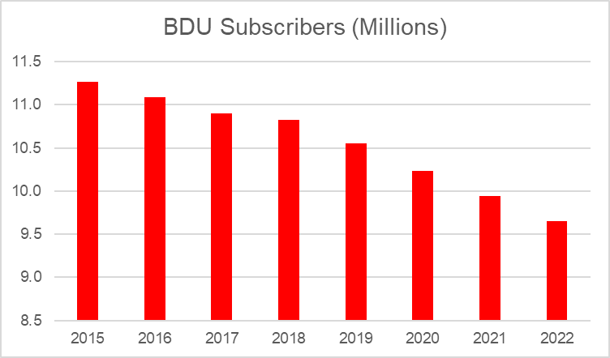

- As revealed by Figure 2, the decline in direct-to-home (DTH) satellite-delivered TV has been even more dramatic. From 2015 to 2022, DTH subscribers have declined by 43% and DTH revenues have decreased by 36%.

Figure 2 – Total Satellite BDU Customers 2015-2022

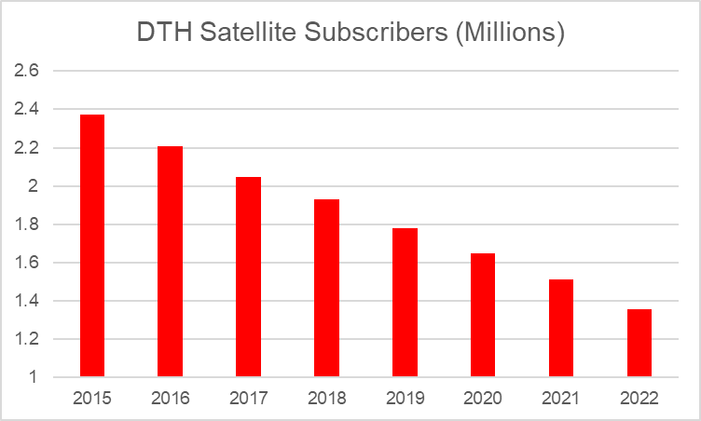

- These cord cutters are turning to a wealth of foreign-owned DMBUs readily available in Canada. Netflix, Amazon Prime Video, Disney+, Apple TV+, and Paramount+ are all growing, and these services compete with Canadian distributors for the same subscribers without being subject to the same regulatory obligations as the traditional broadcasting industry. For example, the Media Technology Monitor Fall 2021 Adoption Report shows that 22% of Anglophones and 15% of Francophones aged 18+ now watch TV exclusively online, up from 5% and 2% respectively in 2012.

- The general decline in BDU revenues and subscribers is mirrored in the financial performance of our wholesale SRDU business (as shown in the next section). The financial performance of the only other SRDU (Shaw Broadcast Services) is not publically available; however, we suspect they are experiencing similar declines.

BELL EXPRESSVU'S SRDU BUSINESS DOES NOT MATERIALLY CONTRIBUTE TO THE OBJECTIVES OF THE ACT

- In this Part 1 Application, we request that the Commission remove the existing obligation of our SRDU to contribute to the creation of Canadian programming. In particular, our SRDU no longer generates sufficient revenues to make a meaningful contribution to the objectives of the Act. Given the de minimus amount of revenue generated by our SRDU, it is no longer reasonable or equitable to require it to make ongoing contributions to Canadian programming. Providing the requested relief represents a small step at establishing equity between SRDUs, BDUs, TRDUs, and digital media undertakings.

- This request aligns with the intent of section 9(4) of the Act, which states that the Commission can exempt undertakings from licensing requirements when those requirements will not contribute in a material manner to the implementation of broadcasting policy.

- Our SRDU business has declined significantly since the Commission last considered the need for licensing. Revenues were # # in 2016 and are now only # #, which represents a # # decline in revenue (or # # in absolute terms).

- In our view, a business generating # # in broadcasting revenues cannot make meaningful contributions to broadcasting policy. In 2023, our SRDU contributed only # # towards the creation of Canadian programming – a large decline from the # # that our SRDU service contributed in 2016. Clearly, our SRDU service is no longer capable of providing meaningful support to the broadcasting system.

- We note that the licensed broadcasting revenue of our SRDU is well below the established threshold for exemption for BDUs. BDUs with fewer than two thousand subscribers are exempt from the requirement to contribute to the creation of Canadian programming. We can estimate the exemption revenue threshold for small BDUs by multiplying the average revenue per user (ARPU) by two thousand subscribers. The Commission's Communications Monitoring Report conveniently provides the data to calculate ARPU for all BDUs.
# Filed in confidence with the CRTC.
- In 2023, subscribers paid an average of $769 a year for BDU service. Multiplying this amount by two thousand subscribers shows that the average exemption threshold for small BDUs is $1.5M. Our SRDU service only generates # # in revenues. This amount is fully # # less than the existing exemption level for small BDUs – the very businesses that often use an SRDU to supplement their programming. It is logically inconsistent that retail BDU providers with two thousand subscribers or less are exempt from contribution requirements while SRDUs, their wholesale partners, are required to contribute despite the fact that they earn significantly less revenue.

THE COMMISSION SHOULD EXEMPT ALL SRDUs FROM REGULATION

SRDU Licensing is Burdensome and Unnecessary

- While this Part 1 Application is a request that the Commission modify the COS of our SRDU by eliminating the requirement that it make contributions to Canadian programming, we believe that SRDUs should be exempted from all regulation. We therefore request that the Commission initiate a policy review on this subject. We believe that current licensing requirements for small SRDU wholesale businesses runs contrary to the Government's 2023 Policy Direction to the Commission to minimize the regulatory burden on traditional broadcasting services.

- First, as discussed above, SRDUs are required to make contributions towards the creation of Canadian programming despite the fact that these contributions are wholly immaterial to the objectives of the Act. They are, however, meaningful to the SRDU businesses themselves, which have been in decline for many years.

- Second, SRDUs must pay Part 1 licence fees to the Commission. Here, we note that exempted BDUs with less than twenty thousand subscribers are not required to pay these fees. We have already demonstrated that exempt BDUs with two thousand subscribers earn more than our SRDU business. However, in this case, one can multiply that inconsistency by a factor of ten. Exempt BDUs with twenty thousand subscribers earn on average $15.4M. This means that our SRDU business, # # of what a large exempt
# Filed in confidence with the CRTC.
BDU earns, must pay licence fees while the exempt BDU does not. We suspect that a single large exempt BDU earns more revenue than all SRDUs combined. Clearly, forcing SRDUs to contribute to licence fees is not reasonable or equitable.

Ø

- Finally, licensing requires small SRDU businesses to provide detailed reports to the Commission each year as part of the Broadcasting Annual Return. SRDUs must prepare these burdensome reports while TRDUs have no such requirement.

The Rationale for SRDU Exemption

- The Commission has periodically reviewed the need to licence SRDU services. In fact, it considered exempting SRDUs in 2008 and 2012. However, in both cases, the Commission declined to exempt SRDUs reasoning that: 1) the annual contribution of SRDUs to Canadian programming was material to the objectives of the Act, and 2) there was insufficient competition from TRDUs in the areas served by SRDUs.

- As discussed above, it is clear that our SRDU no longer makes a material contribution to Canadian programming. We suspect that this is also case for Shaw Broadcast Services, the other licensed Canadian SRDU service. The Canadian SRDU market has been in steady decline since the Commission last considered the possibility of exemption. Given the significant decline in the market, the Commission's previous determination that SRDUs make meaningful contributions to Canadian programming is no longer applicable. SRDUs are niche wholesale businesses that no longer make material contributions to Canadian programming or to the broadcasting system.

- The second reason the Commission did not previously exempt SRDUs from licensing was the claim that there was insufficient competition in the market for the distribution of program signals. In 2012, the Commission acknowledged that there had been increased competition between SRDUs and TRDUs in urban areas, but claimed that this competition was still insufficient to permit exemption. However, since the Commission’s last review, Canadian telecom companies, including Bell Canada, have invested billions of dollars deploying advanced fibre
# Filed in confidence with the CRTC.
networks across the country. These networks now provide significant additional TRDU competition to SRDUs. Moreover, these networks are now extensively available outside of urban areas.

- Despite the significant expansion of terrestrial networks since 2012, there will always be some isolated communities not served by TRDUs. However, this fact is not a sufficient rationale for continuing to license SRDUs.

- Exempting SRDUs does not mean that the Commission must relinquish its role in protecting competition in the market. The Commission’s traditional role in managing disputes between SRDUs, BDUs, and program undertakings can be entrenched within a new SRDU exemption order. Such an exemption order could include language similar to that found in the exemption order respecting TRDUs, which explicitly requires TRDUs to submit to Commission dispute resolution:

If a dispute concerning the terms and conditions under which programming services are or may be provided or distributed arises between the undertaking and a distribution undertaking or a programming undertaking, whether operating by licence or by exemption order, the undertaking submits to such dispute resolution process or processes as may be required by the Commission and to any decision resulting therefrom. [Emphasis added]

- A provision similar to the one above could be included in a SRDU exemption order, and, in this way, the Commission could easily address any potential market abuses. Additionally, we note that there is no evidence of anti-competitive behavior in the market for the distribution of program signals. In our case, there has not been a complaint about our SRDU or TRDU services, including the pricing of the services, in recent memory. Additionally, we are not aware of any complaints against Shaw Broadcast Services.

CONCLUSION

- In this Application, we request that the Commission remove the COS requiring our SRDU to contribute to the creation of Canadian programming. We make this request in light of a rapidly changing business environment in which our SRDU revenues have declined precipitously and competition from unregulated foreign digital undertakings has placed severe stress on our business. Our SRDU no longer makes meaningful contributions to the objectives of the Act and its current regulatory treatment is inconsistent with other exempt undertakings. Eliminating the COS in question would help to alleviate some of the heavy regulatory burden currently shouldered by traditional program distributors and would be in keeping with the Government's recent direction to the Commission.

- We also ask the Commission to initiate a policy review to consider exempting all SRDUs from licensing. Given the evolving broadcasting environment, SRDUs no longer make meaningful contributions to the objectives of the Act. To the extent that the Commission may continue to have concerns about a lack of competition in certain remote areas, these concerns can easily be addressed by mandating Commission dispute resolution for SRDUs, BDUs, and programmers as part of a new exemption order.

*** End of Document ***

We note that the former Conditions of licence (COL) of our SRDU are now considered Conditions of Service. See Broadcasting Information Bulletin CRTC 2023-137, Guidance on the current Broadcasting Act and the transitional provisions of the Online Streaming Act, paragraph 11.
Under the revised Broadcasting Act, as a result of the changes from Bill C-11, COLs are replaced by Conditions of Service. Broadcasting Act (S.C. 1991, c. 11), https://laws-lois.justice.gc.ca/eng/acts/b-9.01/FullText.html.
Appendix to Broadcasting Decision CRTC 2019-385, Conditions of licence for the satellite relay distribution undertaking operated by Bell ExpressVu Inc. (the general partner) and Bell Canada (the limited partner), carrying on business as Bell ExpressVu Limited Partnership.
Broadcasting Order CRTC 2009-638, Amendments to the Exemption order respecting terrestrial relay distribution network undertakings.
Order Issuing a Direction to the CRTC on a Renewed Approach to Telecommunications Policy (SOR/2023-23), https://laws.justice.gc.ca/eng/regulations/SOR-2023-23/. (2023 Policy Direction)
Ibid., section 11.1, paragraph 8(a).
Broadcasting and Telecom Information Bulletin CRTC 2010-961, Procedures for filing confidential information and requesting its disclosure in Commission proceedings, as amended in Broadcasting and Telecom Information Bulletin CRTC 2010-961-1.
Broadcasting Notice of Consultation CRTC 2022-272, Call for comments on an application by TVA to remove the advertising time limit of 12 minutes per clock hour on its discretionary services and on the possibility of removing this limit for other discretionary services, paragraphs 10 and 11.
CRTC, Communications Market Reports – Open Data, Data-BDU, Tab U-T8, Subscribers (millions) of broadcasting distribution undertakings, by type. (CMR Data-BDU)
Ibid., Tab U-T8.
Ibid., Tab UT-6, Revenues ($ billions) of broadcasting distribution undertakings, by type.
Quoted in the CRTC's Annual highlights of the broadcasting sector 2020-2021, page 5, https://crtc.gc.ca/pubs/cmr_broadcasting_2022-en.pdf.
Broadcasting Regulatory Policy CRTC 2012-94, Licensing and other issues relating to satellite relay distribution undertakings.
CMR Data-BDU, Tab U-T5, Evolution of broadcasting distribution revenues ($ billions) and subscribership (millions) compared to the number of households in Canada.
Ibid.
Number of subscribers (20,000) multiplied by average annual revenue per subscriber ($768.94).
Broadcasting Public Notice CRTC 2008-100, Regulatory Policy - Regulatory frameworks for broadcasting distribution undertakings and discretionary programming services, paragraphs 173 to 176.
BRP 2012-94.
Ibid., paragraphs 22 to 25.
Ibid., paragraphs 22 to 23.
Appendix to Broadcasting Order 2009-638, Description, paragraph 5.
More specifically, we have not had a complaint since well-before our licence renewal in 2019.

