Research note: Non-appearing hearings and the CRTC
Forum for Research and Policy in Communications (FRPC)
Ottawa, 17 November 2022

Introduction
When it appeared before the Senate Standing Committee on Transport and Communications (TRCM) in September 2022, the Forum for Research and Policy in Communications (FRPC) recommended that Bill C-11, the Online Streaming Act, be amended to strengthen the transparency of the Canadian Radio-television and Telecommunications Commission (CRTC), the federal tribunal responsible for regulating and supervising Canadian broadcasting. FRPC made similar recommendations in its written brief to TRCM.
The CRTC (represented by its Chair, CRTC General Counsel and CRTC’s Executive Director [Broadcasting]) appeared before TRCM on 16 November 2022, to answer a final round of questions from the members of the Committee.
Senator Fabian Manning asked Ian Scott, the CRTC’s current Chair, about FRPC’s concerns:
Senator Manning: ….
One of the concerns we have heard here is the CRTC’s own lack of transparency and accountability. We had someone from Canada’s Forum for Research and Policy in Communications, who said:
When we say that the CRTC is transparent, it is simply not. It is holding public hearings without witnesses. . . .
Every year, it’s publishing dozens of decisions that you can’t see . . . .
Do you acknowledge that those are serious concerns, especially for smaller players in the broadcasting system, and will also be for digital creators, in particular going forward? Second, what plans does the CRTC have to address those shortcomings that those people have put forward? Do you have any plans to address them?

The CRTC’s Chair said he was “perplexed and confused” about this statement. He went on to say that the CRTC holds all of its proceedings publicly, and that it publishes everything it decides with the exception of information granted confidentiality:
Mr. Scott: I am going to confess, I’m perplexed and confused by the statement. … We hold all of our proceedings publicly. The only things that are held confidential … principally relate to business-confidential matters. … Otherwise, everything we decide upon is a matter of public record.
So I’m not sure what they’re addressing. If they mean our meetings, our deliberations are private, as is any quasi-judicial or judicial body, but the decisions or results of those deliberations are entirely transparent and public. Frankly, I am at a loss to understand where the lack of transparency might be.
….
FRPC therefore decided to update its data concerning non-appearing public hearings and the CRTC’s unpublished broadcasting decisions. Results appear below following a brief discussion of method.

Method
Public hearings:
The CRTC publishes transcripts of the “public hearings” it holds in broadcasting and telecommunications. These can be found, by year, at this link: https://crtc.gc.ca/eng/transcripts/2022/index.htm.
We created a database founded on the transcripts shown for each year from 2017 to 2022. We distinguished between broadcasting and telecommunications hearings, and used the dates of the hearings to determine whether hearings lasted one day or more than one day as well as which Chair was in office at the time. We then reviewed the one-day hearing transcripts to determine whether they involved more than the CRTC’s Commissioners and staff. Altogether we identified 44 CRTC public hearings for which transcripts were published in 2017, 2018, 2019, 2020, 2021 and 2022, of which 38 related to the five-year term of Mr. Scott (from 5 September 2017 to 4 September 2022). Of these 38 transcripts, 36 involved broadcasting matters.
Decisions:
The CRTC has several ways of publishing its decisions. It’s “Today’s Releases” page lists some of its decisions. It also has a page for “Decisions, Notices and Orders”, which again lists certain broadcasting and telecommunications decisions. Finally, however, it has a page that provides information about Broadcasting Applications – the Broadcasting Application Report.
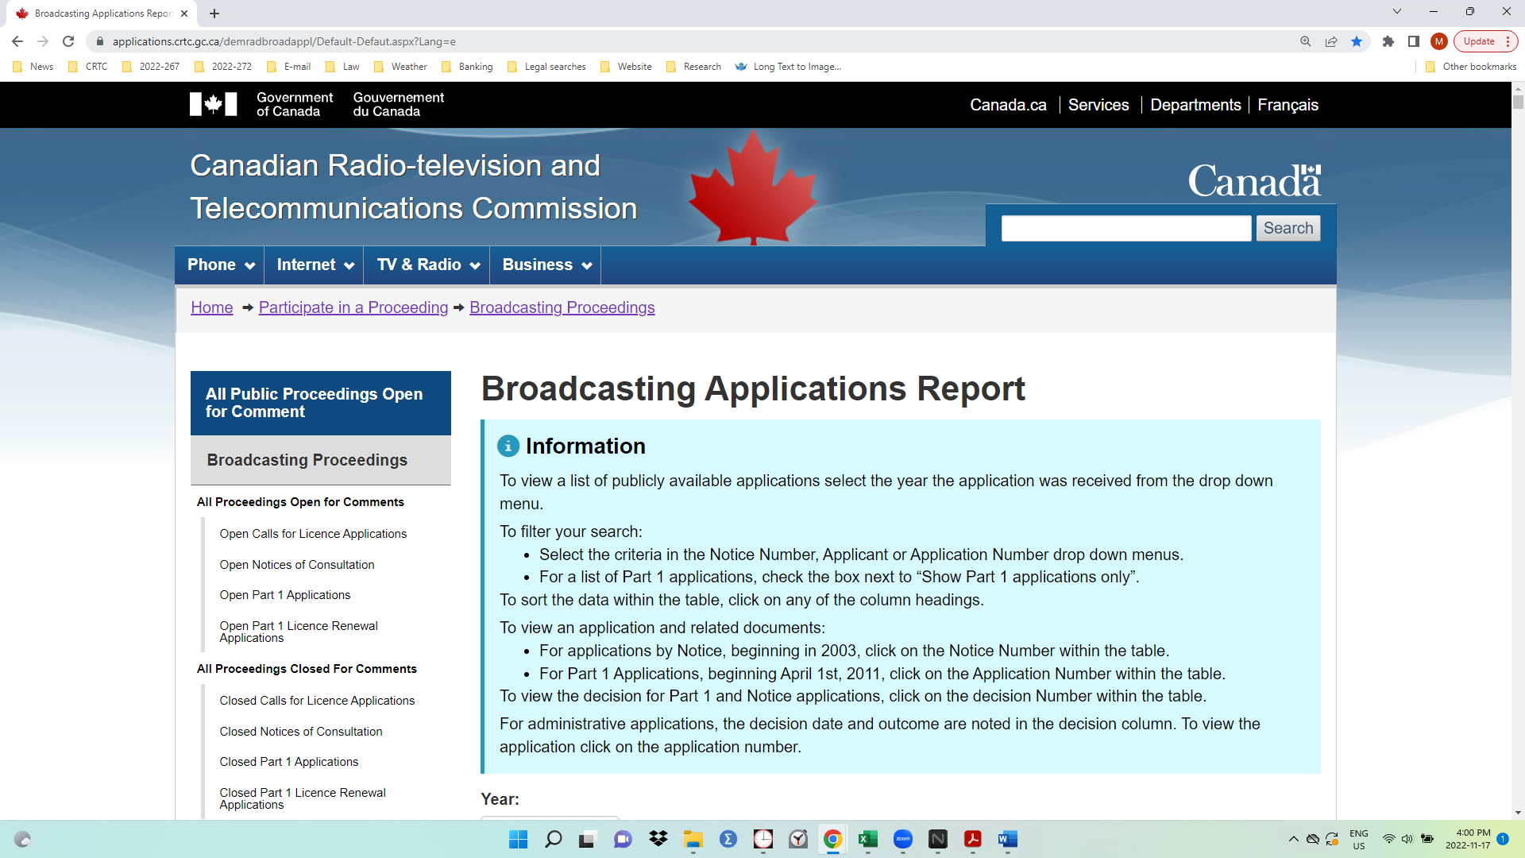
The Broadcasting Applications Report page provides users with the option of reviewing “Administrative” decisions of the CRTC (“Show Administrative applications only”). Selecting the Administrative decisions option yielded 330 decisions, 287 of which were made during Mr. Scott’s full-time term (from 5 September 2017 to 4 September 2022).

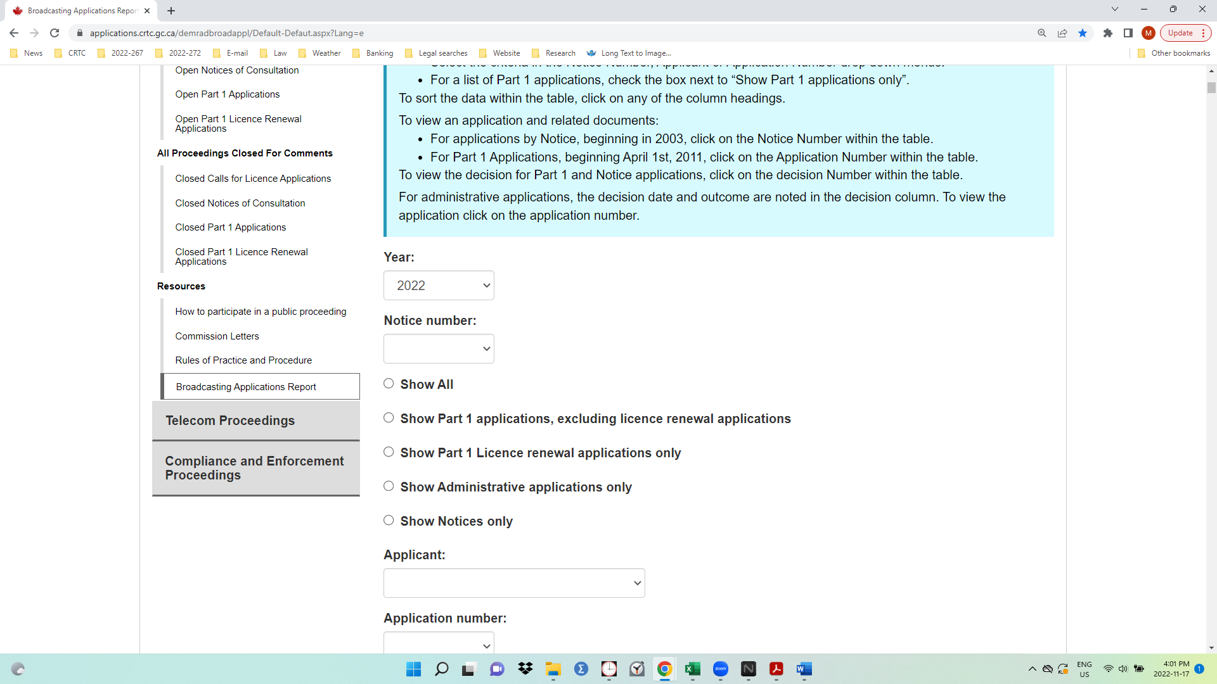
Results
Public hearings
During Mr. Scott’s five-year term the CRTC announced and held 38 public hearings. Of these, 2 were for telecom matters, and the remaining 36 were for broadcasting matters. Of the 36 broadcasting hearings, 11 included representatives of the applicants. The remaining 25 of the public hearings about broadcasting consisted only of CRTC Commissioners and CRTC staff:
Chairperson Scott
Year of term | Broadcasting |  |  | Telecom |  | Total, all hearings
 | Appearing | Non-Appearing | Total | Appearing | Total
2017 | 2 | 1 | 3 |  |  | 3
2018 | 2 | 7 | 9 | 1 | 1 | 10
2019 | 3 | 5 | 8 |  |  | 8
2020 | 2 | 3 | 5 | 1 | 1 | 6
2021 | 2 | 6 | 8 |  |  | 8
2022 |  | 3 | 3 |  |  | 3
Total | 11 | 25 | 36 | 2 | 2 | 38
% of all hearings | 28.9% | 65.8% | 94.7% | 5.3% | 5.3% | 100.0%

The CRTC typically announces the non-appearing character of its public hearings in its Notices of Consultation. For example, in 2021 it announced it was holding a public hearing “without the appearance of the parties”, to consider two applications – one involving a change in ownership and one for a new radio station licence:
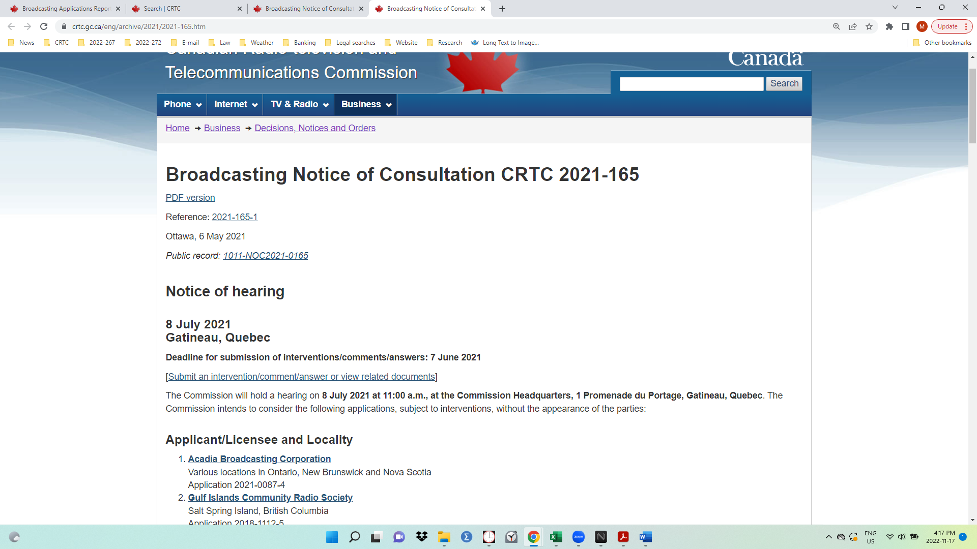

Unpublished decisions
One way of locating information published by the CRTC is through its “A-Z Index”. This Index lists “Decisions”, which links to a page entitled “Decisions, Notices and Orders – Indexes”. Those decisions are publicly accessible through HTML links along with their associated applications.
The CRTC also makes decisions about “Administrative applications”, but these can only be found by studying a CRTC page that lists “publicly available” broadcasting applications: the Broadcasting Applications Report (BAR).
The CRTC’s BAR page includes an option to display “Administrative applications only”. Selecting this option presents applications and the related CRTC decisions’ number, date and decision status, for each year from 2012 to the present. No HTML links are provided for these decisions, and they do not appear when searched for using the CRTC’s search engine.
During the most recently-completed five-year term of the CRTC’s current Chair, the CRTC issued 287 broadcasting decisions that are unavailable to the public, granting all but one of the related applications. More than two-thirds (199, or 39.3%) dealt with applications to amend the technical parameters of a licence or with requests for extension of time to complete deadlines set out in prior CRTC deadlines, but 45 (15.7%) involved applications related to changes in ownership and/or control:
CRTC’s “administrative” applications and unpublished decisions during Chairperson’s Scott’s term
(5 September 2017 – 4 September 2022)
Type of application | Number of applications & decisions | Percentage
Amendment - technical | 106 | 36.9%
Extension - time | 93 | 32.4%
Ownership | 45 | 15.7%
Deleted rebroad | 14 | 4.9%
Dondition of licence - programming | 7 | 2.4%
Deleted area | 7 | 2.4%
Licence - amendment | 3 | 1.0%
Adult programming | 2 | 0.7%
Relocation - transmitter | 2 | 0.7%
Removal - transmitter | 2 | 0.7%
Addition - rebroadcaster | 1 | 0.3%
Amendment - temp relief - programming | 1 | 0.3%
Condition of licence - temporary relief | 1 | 0.3%
Extension - temp management authorization | 1 | 0.3%
Transmitter - transfer | 1 | 0.3%
Transmitter -temp | 1 | 0.3%
Re-organization |  | 0.0%
Total | 287 | 100.0%

None of the 287 applications about which the CRTC made decisions was issued before the CRTC made its decisions: 43 were made public the day the CRTC made its decision and 242 were published after the decision was made. In two cases no information was provided about the date on which the application was published.

Conclusions
Public hearings
It is obviously important for the CRTC to be able to manage its resources carefully and effectively. Until the last several years its practice regarding appearing public hearings was to rent space for the hearings; its offices typically provide room for its staff, not large meetings.
The 2020-21 global pandemic led the CRTC to adopt Internet-based hearings, however, in which applicants and interveners ‘appear’ before the Commission’s hearing panels via a Zoom-type of service. Such hearings may result in significant savings for the Commission. The existence of relatively inexpensive online hearings therefore raises the question of whether the CRTC should continue to hold the majority (69%) of its ‘public hearings’ without actually allowing non-CRTC officials to participate. At present it is somewhat unclear what leads the CRTC to decide that the written evidence is so compelling that it need not question the licensees or interveners in person.
Moreover, the shift from actual public hearings where applicants and interveners may respond to the CRTC and each other to non-appearing hearings would appear to defeat another purpose of public hearings: to provide other existing or potential broadcasters with an example of the consequences of failing to comply with Canada’s legislative and regulatory requirements for broadcasting. The Forum’s concern is that using non-appearing ‘public hearings’ to address regulatory non-compliance may signal that the CRTC no longer considers certain types of non-compliance especially serious.
Decisions
As with public hearings, it is important for the CRTC to manage its proceedings efficiently, and it is clear that some applications warrant urgent or expedited treatment: matters involving the transfer of control over estates of recently deceased licensees, for example, or to enable ownership transactions to be concluded expeditiously.
As the CRTC does not publish the actual decisions it is making, however, it is unclear whether
a) the CRTC sets out its reasons for deciding not to publish such applications for public review and for not inviting public comment, and
b) whether the CRTC’s decisions set out its approach to implementing Parliament’s broadcasting policy for Canada.
What is clear is that the CRTC’s current approach to certain “administrative” decisions – a category of decision that is not set out in the 1991 Broadcasting Act – prevents Canadians and interested parties from reviewing the applications and providing their views before the CRTC makes its decisions, and also prevents these decisions from being reviewed at all.
The Forum’s concern is that the CRTC’s choice to keep hundreds of such decisions from public review is entirely the opposite of its stated commitment to transparency and accountability.
