English-language Arts Network (ELAN)
Quebec Community Groups Network (QCGN)
Quebec English-language Production Council (QEPC)

January 11, 2019

Janet Yale
Chair
Broadcasting and Telecommunications Legislative Review Secretariat
235 Queen Street, 1st Floor
Ottawa, ON
K1A 0H5
ic.btlr-elmrt.ic@canada.ca

Dear Ms. Yale,

Re: English OLMC Comments on the
Broadcasting and Telecommunications Legislative Review

- Introduction

The following associations represent the Official Language Minority Communities (OLMCs) in Quebec. We will focus in this submission on our experience with the Broadcasting Act, and make recommendations for changes in a new Act that will better support official language minority communities and their production.

The English-Language Arts Network (ELAN) represents over 8,000 English-speaking artists in Quebec. The Quebec Community Groups Network (QCGN) officially represents Quebec's English-speaking community but, in the complex realm of broadcasting, QCGN calls upon ELAN to use its expertise to intervene on behalf of the English-speaking community of Quebec, which represents the 750,000 English-speakers in the Greater Montreal area, and another 250,000 in the regions outside Montreal. Priority interests for the official language minority community (OLMC) are local content and regional reflection.

Founded in 1995, the Quebec Community Groups Network (QCGN) is a not-for-profit organization linking more than 50 English-language community organizations across Quebec. As a centre of evidence-based expertise and collective action, the QCGN identifies, explores and addresses strategic issues affecting the development and vitality of the English-speaking community of Quebec and encourages dialogue and collaboration among its member organizations, individuals, community groups, institutions and leaders.

The Quebec English-language Production Council (QEPC) represents the official language minority (OLMC) film and television production industry in Quebec, including most independent Quebec producers of English-language programming, as well as ACTRA Montreal. We represent approximately 80% of those working in the OLMC industry.

- Background

The impact of CRTC decisions on OLMC production has been major, and despite the good will of many Commissioners and staff, on balance it has been very negative. As a result, OLMC production in Quebec has faced systemic decline over the last seventeen years.

Attempts to solve this problem by appealing to both the Commissioner of Official Languages and the CRTC have not reversed this decline. Appeals to the Department of Canadian Heritage have been ignored. Official language minorities, which soon may include Indigenous languages, need stronger and clearer legislative direction in both the Broadcasting Act and the Official Languages Act.

- Impact of CRTC’s OLMC Decisions

Disaster - Impact of CRTC 1999-97 on English OLMC Production

CRTC 1997-99, “Building on Success, A Policy Framework for Canadian Television”, was arguably the worst blunder in the history of the CRTC. We will never know how much total Cancon production was lost as a result. We do know it was the worst decision in the history of English OLMC production.

The reason was the elimination of the private broadcaster spending quota for Canadian programming. The CRTC decided that:

“The regulatory requirement for expenditures on Canadian programming will be eliminated effective 1 September 2000.“

In the case of English OLMC production, we lost $122 million the year this decision took effect in 2000-01. Before this decision took effect, Quebec averaged 24% of total English-language production. After it took effect, we have averaged 11%.

This missing OLMC production moved mainly to Toronto. Ontario averaged 48% of total English Cancon before 2000-01, and 56% afterwards. B.C. improved slightly on average, from 18% to 19%. Prairies went up slightly from 6% to 7%, and Atlantic remained at an average 5%.

As a result of CRTC 1999-97, total Canadian production did not increase as much as it should have. We will never know how total Canadian production would have evolved without CRTC 1999-97, or how much Cancon was lost because of it. However, from this re-distribution of actual production, we can see the regional impact was felt disproportionately, almost entirely, by the EN OLMC . Our losses were an unmitigated disaster.

We have looked diligently among provincial and federal policies, such as the tax credit, to explain this drop beginning in 2000-01. We have found nothing except CRTC 1999-97.

If instead of 11% of total English production, we had maintained our share of national production and averaged 20% over the last 17 years, we would have increased our actual production by an average of $129M every year. That is a total of more than $2 billion in lost OLMC production as a result of this one CRTC decision… and we are still dealing with the impact.

Pushed by the production industry, the CRTC eventually recognized that CRTC 1999-97 was a serious error. The Commission re-established a Canadian Programming Expenditure (CPE) requirement in CRTC 2010-167 “A group-based approach to the licensing of private television services”. The Commission decided that:

“First, in order to ensure that the designated groups continue to contribute to the creation of Canadian programming, the Commission will establish a minimum, aggregate level of spending on Canadian programs for each designated group.”

Unfortunately, that correction and re-establishment of a minimum 30% CPE for private broadcasters did not repair the damage that CRTC 1999-97 had done. Between 2000 and 2010, OLMC writers, directors, producers, and others had followed production work mainly to Toronto, but also to Vancouver, Prairies, and Los Angeles. This amounted to an irreversible exodus of OLMC talent.

Although production ranges up and down each year, OLMC production has not recovered. In fact, our worst year was 2015-16 with only $128M in production. This was only 7% of total English production.

More recently, we see two conflicting trends in the CRTC’s OLMC decisions.

Positive Trend- CRTC OLMC Decisions from 2011 to 2013

CRTC decisions from 2011 to 2013 often created a quota for OLMC production. Quotas have proved to be the most effective mechanism to support OLMC production.

The following are examples of the first trend (2011 to 2013) which have proved to be effective.

- CRTC 2011-441 was the first decision where the CRTC seems to have consciously tried to support the English OLMC. The steps were tentative, but went in the right direction. In that decision, the Commission gave regional status to EN OLMC production, and requested that the CMF do the same thing. This decision asked private broadcasters to begin collecting OLMC data.

- To facilitate the purchase of a conventional TV station in Montreal in 2012, Rogers offered to allocate a minimum of 3% of its independent TV production expenditures to EN OLMC producers. In CRTC 2012-697, the CRTC accepted this offer. This was the first EN OLMC quota.

- Due in whole or in part to the stronger support for OLMC production in the CBC sections of the Broadcasting Act, the CRTC did establish various OLMC production requirements in its 2013 CBC licence renewal by condition of licence. CRTC 2013-263 set a minimum EN OLMC production level of 6% of CBC’s total English independent production funding. It also set an OLMC minimum of 10% of CBC’s development budget.

On the French side, CRTC did not establish a FR OLMC minimum, but a regional minimum for production outside of Montreal (including both OLMC and Quebec regional production). CRTC 2013-263 set this regional minimum at 6% of SRC’s independent production.

In addition, CRTC set a FR OLMC minimum of 20% of ARTV’s original production, of which half, or 10% of original programming, should be independent production.

- In the case of the Bell tangible benefits as part of its purchase of Astral (CRTC 2013-310), Bell promised to spend 10% of its English tangible benefits on OLMC production. This was the second private broadcaster OLMC quota as well as the CBC’s quotas.

We could see the positive impact of these decisions in our annual review of OLMC production statistics.

Negative Trend- CRTC OLMC Decisions from 2015 to the present

CRTC decisions from 2015 to the present have avoided OLMC quotas and tried to find other approaches. The following are examples from this second CRTC trend.

The CRTC changed its approach from a minimum OLMC quota of national independent production to other more complicated, sometimes contradictory, approaches. These decisions represented a significant shift in CRTC thinking, and seemed aimed at helping the licensee as much or more than the OLMC.

- In CRTC 2015-32, the Commission rejected a Videotron request to fund an EN OLMC community channel in Montreal, contrary to the precedent Rogers had established in Ottawa and Moncton for the FR OLMC. The recent renewal of funding for the Rogers’ FR OLMC community channels in Ottawa and Moncton stands in sharp contrast to Videotron’s unfunded EN OLMC community channel application in Montreal.

The reason given for the funding of FR OLMC community channels in Moncton and Ottawa, and the rejection of funding for an EN OLMC community channel in Montreal, was financial. The CRTC believed the Montreal community channel would have taken too much funding from CMF revenues. This may be true. However, CRTC did not try to find a compromise decision, but simply rejected all funding for an EN OLMC channel.

Without new funding for a full EN OLMC community channel, Videotron established a 20% EN OLMC share of its Montreal community channel MATV. This 20-80 division applied to both broadcast time and budget between the English and French MATV service. This was a Videotron decision, and not a CRTC requirement. Therefore, Videotron can reverse that 20% English share of MATV at any time, or even move English MATV funding to support French local news.

- CRTC 2016-343 “The Canadian Independent Production Fund Policy Framework” is an example of an extremely weak OLMC decision. Both the English OLMC film industry represented by QEPC, and the French OLMC industry represented by APFC, requested a 10% OLMC quota for the CIPFs.

CRTC rejected these requests. Instead, the Commission said it “…will require CIPFs to have at least one CIPF project selection committee member who is responsible for the consideration of OLMCs’ realities”, and “…in their annual reports, CIPFs will also be required to report on their activities related to OLMCs and how they have ensured proper reflection of these communities”. One person on the selection committee must consider OLMC realities, and then report on the results of those considerations. The CRTC does not say how much OLMC reflection would be “proper”. There is no minimum requirement for OLMC programming, only a requirement that OLMC realities be considered.

- The English private broadcast group licence renewal (CRTC 2017-148) was unprecedented because the CRTC set OLMC and Indigenous objectives in competition with each other. The CRTC created a complicated and competitive bonus. The OLMC bonus was 25% and the Indigenous bonus was 50% of CPE requirements. However, there is a common 10% cap which applies to both bonuses. This means OLMC and Indigenous producers are in competition with each other for bonus funding. The more OLMC producers use their bonus, the fewer bonus funds are available for Indigenous producers, and vice versa.

The Governor-in-Council asked the CRTC to review these decisions (2017-143 to 2017-151), but did not include the OLMC-Indigenous competitive bonus in the review. Interventions protesting this “competitive OLMC/Indigenous bonus” by QEPC, APTN, and others were made to no avail.

- In the Rogers’ Montreal CJNT-DT licence renewal (CRTC 2017-151), the CRTC did not require the 3% EN OLMC quota (established in 2012-697) be continued. In fact, the CJNT morning news program in Montreal was discontinued, apparently without other OLMC compensation. The CRTC staff explanation was that now we had the competitive OLMC/Indigenous bonus, so there was no need for an OLMC quota.

- In its Videotron licence renewal decision CRTC 2018-269, the Commission rejected ELAN’s request that this 20% EN OLMC community service on MATV become a condition of Videotron’s licence. CRTC also rejected ELAN’s request that other Videotron community channels in Quebec establish a 10% EN OLMC community service.

Attempts to reverse the course of our production decline have not been entirely successful because the Broadcasting Act provides no specific support for OLMCs except in the case of the CBC. At best, we can say that our efforts for the last ten years have arrested, but not reversed, that decline.

Why has the CRTC changed its approach to OLMC production since 2015? Probably because of changes in Commission appointments. Whatever the cause, these decisions demonstrate that the current Broadcasting Act is unable to protect OLMC needs. We need the OLMC protections in the Act to be strong enough to weather changes in CRTC personnel.

- Commissioner of Official Languages’ Decision concerning EN OLMC, PCH, and CMF

Prior to 2010, we do not think the CRTC or PCH seriously considered the impact of their decisions on the English-Quebec minority. We were often confused with English-language regions by policy-makers who focussed on the French-language minority. As a result, the English-language minority in Quebec suffered from ignorance and neglect.

The Department of Canadian Heritage funding of the Canada Media Fund is a case in point. In 2010, QEPC filed a complaint with the Commissioner of Official Languages (OCOL) against PCH policies that allowed the CMF to treat the English OLMC as no different than any other English region, and not equivalent to the French OLMC.

OCOL decided that the production industry was important to the vitality of the English OLMC and began its three-year investigation of CMF Guidelines.

In defence against the QEPC complaint, PCH put the demographic case to OCOL that the English OLMC was only 3.4% of the total population. At an average of 9% of the English total (before 2010), CMF funding of English OLMC production was much higher than the demographic weight of the English minority. Therefore, PCH said no improvement in CMF funding was necessary.

OCOL rejected PCH’s demographic argument. In its report, OCOL said that funding should be based on OLMC “needs” rather than “a per capita funding analysis comparison between the two minority communities”. OCOL emphasized that “Each OLMC has its own particular set of challenges that must be identified in order to develop programs or policies that respond to the specific needs of that community”.

Since 2010, without a minimum CMF requirement, EN OLMC production has ranged from 4% to 9.5% of the CMF’s total English envelope. With the 10% minimum requirement, FR OLMC production has ranged from 10.1% to 12.5% of the total French envelope.

In 2013, Commissioner Graham Fraser agreed with our complaint, and decided in QEPC’s favour. This decision created or reinforced a number of important precedents, especially that OLMC support should be based on “need” and not demographic share of the population.

The OCOL decision stated:

“Based on the observations and findings in this report, I recommend to the Department of Canadian Heritage that it:

- Include a provision that recognizes the English OLMC in the next contribution agreement that is signed with the Canada Media Fund for fiscal year 2013-2014.

- Take measures, by end of fiscal year 2012-2013, to mitigate the impact of the uncertainty in yearly funding on the vitality and development of English OLMC.”

The OCOL recommendation that PCH “mitigate the impact of the uncertainty in yearly funding” was vague. It led to the positive outcome of the establishment of the Anglophone Minority Incentive (AMI) fund. Unfortunately, as CMF funding has been in decline, the AMI has remained badly underfunded. Without a minimum 10% of the linguistic envelope as QEPC has requested, and as the French OLMC has had, EN OLMC production has not recovered its vitality.

See the appended letter dated May 7, 2018 to Jérémy Gauthier, Policy Advisor, Minister of Canadian Heritage (Mme. Joly at this time). We were subsequently told by M. Gauthier that the Minister would take no action on this issue until she had heard from your panel.

Therefore, we hope your panel addresses this issue, and our belief that under the Official Languages Act, both OLMCs should be treated equivalently by CMF. While there are obvious differences in our needs, we believe OLMCs should be treated equivalently under the Broadcasting Act as well.

In our draft revisions of the Broadcasting Act, we have recommended that the Canada Media Fund be included in the Act, along with the CRTC and the CBC. In addition, we have requested that at least 10% of all CMF production funding be allocated to OLMCs which we have defined as English, French, and Indigenous language minorities.

- Selected Questions as set out in the Terms of Reference

We have focussed on questions that we believe are relevant to Official Language Minorities.

8.2 How can legislation promote access to Canadian voices on the Internet, in both official languages, and on all platforms?

We believe this is a matter of cultural sovereignty. Legislation must make Canadian cultural sovereignty over all means of communications within Canada clear, evident, and effective. Access to the Canadian communications system, and funding of Canadian content, must be legislated by the Government, and enforced by the regulator. Therefore:

We must replace the “New Media Exemption Order” which allows foreign digital “over-the-tops”, like Netflix, Google, or Facebook to operate in Canada without effective regulation. We need a regulatory regime that does not exempt these companies from regulation, and is applicable to all communications media in Canada.

As part of this regime, we must require that Canadian channels have access to the communications distribution system, and Canadian content has access to all appropriate platforms. Foreign channels and foreign content should have regulated access to the Canadian market.

We must require a minimum percentage of Canadian content on important platforms.

We must require that a minimum percentage of the revenues generated from the Canadian market are spent on Canadian content.

The regulator should have the authority to require Canadian access to the communications media, fund Canadian content from any revenues generated by the communications media in Canada, and fine or penalize any communications operator which flouts regulatory or national authority.

Furthermore, at least 10% of total Canadian content revenues must be spent on OLMC content.

9.2 Should certain objectives be prioritized? If so, which ones? What should be added?

The priority should be the production and dissemination of Canadian content.

10.1 How can we ensure that Canadian and non-Canadian online players play a role in supporting the creation, production, and distribution of Canadian content?

We should require that all online players be subject to Canadian sovereignty, legislation, taxation, and regulation. To date, it seems major American online players do not want to ignore national sovereignty over communications media. Their strategy appears to be to minimize impact of national sovereignty through lobbying efforts, rather than by flouting national laws. And lobby they do.

10.2 How can the CRTC be empowered to implement and regulate according to a modernized Broadcasting Act in order to protect, support, and promote our culture in both official languages?

As discussed elsewhere in this document, OLMC quotas are the most effective means of promoting OLMC production. The CRTC has the power to impose quotas, and did it in 2013 with CBC as a condition of licence. With private broadcasters, the issue has been less clear-cut. The CRTC has accepted private broadcaster proposals for a 3% OLMC quota in the case of Rogers in 2012, and a 10% OLMC quota proposed in 2013 by Bell for tangible benefits.

More recently, the CRTC has rejected OLMC quotas in its decisions. We believe the solution is to strengthen the requirements in the Broadcasting Act to support OLMC production, including Indigenous language production. While the regulator needs flexibility in its decision-making, we should not be subject to extreme OLMC policy fluctuations as a result of Commission personnel turnover.

13.5 How can CBC/Radio-Canada contribute to reconciliation with Indigenous Peoples and the telling of Indigenous stories by Indigenous Peoples?

The CBC/SRC has a major role to play in the production and distribution of Indigenous programming and in the support of Indigenous languages. This role should be defined more clearly in the Broadcasting Act. As well, funding of the CBC/SRC should take into account its OLMC obligations over time. CBC/SRC funding should be stabilized at a level appropriate for its role on at least a five year term.

13.6 How can CBC/Radio-Canada support and protect the vitality of Canada’s official languages and official language minority communities?

CBC/SRC should not be the only broadcaster with an obligation to support OLMC program production. For that reason, we have proposed changes to the Broadcasting Act which more clearly define the obligations of private broadcasters and distributors.

The CBC/SRC should broadcast or distribute OLMC programming in all media and platforms available, including radio and online services, as well as television. At least 10% of independent and other production should be produced by OLMCs, and to the degree possible, reflect OLMCs, and tell OLMC stories.

14.4 Are there tools that the CRTC does not have in the Broadcasting Act that it should?

The CRTC should have the power to levy significant fines, up to as much as $25 million for Canadian broadcasters and distributors and $50 million or more for foreign entities.

14.5 How can accountability and transparency in the availability and discovery of digital cultural content be enabled, notably with access to local content?

In general, accountability and transparency is encouraged by the generation and publication of statistical data. The CRTC should strive to allow as much data as possible to become public. It ought to create clear and tough standards to minimize the amount of commercial data kept from the public.

- Proposed Changes to the Broadcasting Act in support of Official Language Minority Programming

These comments explain our thinking behind changes we recommend to the Broadcasting Act. Changes recommended in the current Act are indicated in yellow highlight. OLMC references in the current Act are indicated in blue.

S.2(3) This Act shall be construed and applied in a manner that
(a) is consistent with the freedom of expression and journalistic, creative and programming independence enjoyed by broadcasting undertakings; and
(b) supports the commitment of the Government of Canada to enhance the vitality of official language minority communities in Canada.

We recommend that the Interpretation section of the Broadcasting Act be expanded to include support for the OLMCs in Canada. We base s.2(3)(b) of the new Act on the precedent of s.3(3)(d) and s.3(3)(e) of the Immigration and Refugee Protection Act.

We believe OLMCs should include Indigenous languages as well as French-speakers living outside Quebec and English-speakers living inside Quebec. However, we will leave it to others to define Indigenous linguistic minorities.

Roughly one million English-speakers live in Quebec, one million French-speakers reside outside Quebec, and in addition there are a quarter-million Indigenous-speakers living in Canada. The crucial issue is the status and vitality of these linguistic communities, and what legislative protections can be provided within the terms of the Broadcasting Act.

S.3(1)d the Canadian broadcasting system shall
s. 3(1)d(v) “provide resources to programs produced by official language minority communities or reflecting the history or culture of such communities”.

We have added this section to indicate that the resources should be found within the entire broadcasting system to fund competitive OLMC programming. We believe it is the responsibility of Parliament to ensure the necessary funding from the entire system, whether from public or private, or Canadian or non-Canadian sources. It is then the responsibility of the regulator to fulfill Parliament’s wishes.

We have further said that this OLMC programming may “reflect” the history or culture of OLMCs. We believe that original English-language OLMC programs should be located or shot in Quebec to the degree possible by a Quebec-based production company. They should be of competitive quality needed to attract local, national and international audiences, as well as foreign investment. The situation may be different for FR OLMC programming which may not be able to attract significant foreign investment regardless of quality. Obviously it will be different for Indigenous language production which may only have a local audience, and no commercial market.

Funding for OLMC programming should be based on the needs of each community to remain or become vital, and not demographic, commercial, or other factors. Based on CAVCO data, the EN OLMC averaged 24% of total English production before 2001, and has averaged 11% since 2001. English OLMC production remains in jeopardy. We believe the EN OLMC needs at least 10% of total English production funding to maintain current production levels and not decline further.

S.3(1)(k) “a range of broadcasting services in English and in French shall be extended to all Canadians, and reflect the particular needs and circumstances of official linguistic minorities,”

We have expanded this section to say that the Canadian broadcasting system should extend services in English and French to all Canadians, and in this process, reflect the particular needs and circumstances of their linguistic minorities.

S.3(1)(m)(iv) be in English and in French, reflecting the different needs and circumstances of each official language community, including the particular needs and circumstances of English, French, and Indigenous linguistic minorities,
For greater clarity, we have added the word “Indigenous” to linguistic minorities. This section sets out the OLMC responsibilities of the CBC/SRC. The other sections above refer to the entire broadcasting system.

S.3(1)(r)(iii) reflect Canada’s regions, official language minorities, and multicultural nature,

This section applies to “alternative programming services” which are not specifically defined in the Act.

S.3(1)(s)(i) contribute significantly to the creation and presentation of Canadian programming, including regional and official language minority programming,

This section applies to “private networks and programming undertakings” which should produce programming “…to an extent consistent with the financial and other resources available to them”. So the regulator would decide whether these private networks and programming undertakings would have the financial resources needed to produce Canadian, regional, or OLMC programming.

S.3(1)(t)(iv) may, where the Commission considers it appropriate, originate programming, including local programming, on such terms as are conducive to the achievement of the objectives of the broadcasting policy set out in this subsection, and in particular provide access for underserved linguistic and cultural minority communities.

This section applies to “distribution undertakings”. We have not changed this wording since the current Act indicates that the CRTC should provide access to OLMCs based on the programming objectives in the rest of S.3. We have recommended changes to those programming objectives to include OLMCs.

S.5(2) The Canadian broadcasting system should be regulated and supervised in a flexible manner that
(a) is readily adaptable to the different characteristics of English and French language broadcasting and to the different conditions under which broadcasting undertakings that provide English or French language programming operate;
(b) takes into account regional needs and concerns;
(x) takes into account the needs and concerns of the official language minorities;
(y) gathers and publishes aggregate production and other data from all broadcasters and distributors operating in Canada;

We have added two sections to the responsibilities set out in S.5(2) of the Act which applies to the CRTC. Section (a) is currently in the Act, but does not specifically address CRTC responsibilities to OLMCs. For that reason, we have added section (x).

Section (y) requires that the CRTC collect and publish aggregate production and other data from all broadcasters and distributors operating in Canada. That means foreign OTTs as well as Canadian services licensed or not. This is also needed as part of its “duty to consult” to understand OLMC needs and concerns.

We believe the requirement to be licensed to operate a business is the first demonstration of cultural sovereignty. The requirement to provide data is the second demonstration of cultural sovereignty. The third is the requirement to pay taxes or other fees.

S.7(7) Obligation to enhance the vitality of official language minority communities
In regulating and supervising the Canadian broadcasting system and exercising its powers under this Act, the Commission shall take the necessary measures to enhance the vitality of official language minority communities and support and assist their development.

S.7(7) Duty to consult official language minority communities
(1) It is the duty of the Commission to consult with official language minority communities when making regulations under this Act and whenever its decisions could adversely affect official language minority communities.
(2) When engaging in consultation pursuant to subsection (1), the Commission shall
a) gather information to test its policies, decisions and programs;
b) propose policies, decisions and programs that have not been finalized;
c) seek the opinions of the communities consulted with regard to the policies, decisions or programs;
d) provide the communities consulted with all relevant information on which these policies, decisions or programs are based;
e) listen with an open mind to what the communities consulted have to say;
f) be prepared to alter the policies, decisions or programs that are the subject of the consultation; and
g) provide feedback to the communities consulted, both during the consultation process and after the decision has been taken.

In Haida Nation v British Columbia (2004 SCC 73), the Supreme Court of Canada explained the parameters of the Crown’s duty to consult Indigenous peoples prior to making decisions that might adversely affect their rights. “Meaningful consultation”, according to the Supreme Court, includes: gathering information to test policy proposals; putting forward proposals that are not yet finalized; seeking the community’s opinion on the proposals; informing the community of all relevant information upon which those proposals are based; listening to communities with an open mind; and being prepared to alter the original proposal (paragraph 46 of the Haida decision).

We wish to apply this precedent to the Broadcasting Act to clarify the “duty to consult” OLMCs applicable to the CRTC, CBC, and also CMF which we believe should be included in the Act.

S.46(4) In planning extensions of broadcasting services, or undertaking programming decisions, the Corporation shall have regard to the principles and purposes of the Official Languages Act.

This section applies to the Objects and Powers of the CBC/SRC. At present, the Act says the CBC/SRC should have regard for the principles and purposes of the OLA when planning extensions of broadcasting services. We have added a similar caveat when CBC/SRC is undertaking programming decisions as well.

S.46(6) Obligation to enhance the vitality of official language minority communities
In exercising its powers under this Act, the Corporation shall take the necessary measures to enhance the vitality of official language minority communities and support and assist their development.
S.46(7) Duty to consult official language minority communities
(1) It is the duty of the Corporation to consult with official language minority communities when making regulations under this Act and whenever its decisions could adversely affect official language minority communities.
(2) When engaging in consultation pursuant to subsection (1), the Commission shall
a) gather information to test its policies, decisions and programs;
b) propose policies, decisions and programs that have not been finalized;
c) seek the opinions of the communities consulted with regard to the policies, decisions or programs;
d) provide the communities consulted with all relevant information on which these policies, decisions or programs are based;
e) listen with an open mind to what the communities consulted have to say;
f) be prepared to alter the policies, decisions or programs that are the subject of the consultation; and
g) provide feedback to the communities consulted, both during the consultation process and after the decision has been taken.

This section repeats and extends the “duty to consult” and other OLMC obligations to the CBC.

PART (x) Objects and Powers of the Canada Media Fund in Relation to Broadcasting
The objects and powers largely set out in the annual PCH-CMF Contribution Agreement should be incorporated to a certain degree into the Broadcasting Act. Note Appendix A Funding Criteria 4 of the Contribution Agreement.

Official language minority production, including French, English, and Indigenous programming, should include a dedicated fund for each linguistic minority. OLMC programming should be funded according to the needs of each community, and total OLMC funding should be at least 10% of the total CMF production budget.

The CMF should be regulated by the CRTC.

The CMF is now subject to the Official Languages Act and has an obligation to enhance the vitality of OLMCs, and it has a “duty to consult” OLMCs as does CRTC and CBC. Our recommended sections for CRTC and CBC/SRC should be included for the CMF as well.

The current Act incorporates the CBC/SRC and CRTC within its legislation. It is the legislation under which the CBC/SRC operates. In the case of the CRTC, there is also the CRTC Act (which is not within the mandate of your panel), but the policy objectives given to the CRTC are in the Broadcasting Act.

We believe the Canada Media Fund’s policy objectives should be included in the new Act.

At present the CMF is a public-private non-profit organization. It’s public policy objectives are included in the PCH-CMF Contribution Agreement which it negotiates every year with PCH. This Agreement provides the OLMC requirements of the CMF which is also subject to the authority of the Official Languages Act.

The CMF must spend at least 10% of the French production envelope on FR OLMC production. There is no such minimum spend requirement for EN OLMC production. As we explain above, there is the Anglophone Minority Incentive fund which is inadequate to the EN OLMC’s needs. It also does not have a minimum funding requirement, unlike the FR OLMC.

See below the specific OLMC, Indigenous, and other obligations in the Contribution Agreement that PCH requires CMF fulfill:

“The [CMF]Corporation shall:
(i) meet the Government’s policy objective of supporting French-language minority
productions by ensuring a minimum 10% funding envelope, calculated on the
amount allocated for French-language productions;
(ii) consider what measures may be appropriate to address the impact, if any, of the
uncertainty in yearly funding levels on the vitality and development of English language
minority communities;
(iii) encourage television convergent production by both majority and minority official
language sectors;
(iv) support Aboriginal languages convergent television productions by a dedicated
envelope;
(v) support television convergent productions in third languages where demand and
funding are present;
(vi) ensure funding support to regional television convergent productions;
(vii) ensure priority is given to high-definition productions;
(viii) ensure the establishment of benchmarks for target audience numbers to assist in
assessing applications for funding; and
(ix) ensure a gradual integration of broadcasters as ultimate recipients to allow for a
(x) gradual adjustment by all recipients to the CMFs conditions. “

When Minister Joly was the Minister of Canadian Heritage, we requested that the EN OLMC receive the same treatment as the FR OLMC, i.e. 10% of the English production envelope. We were told that she would not consider that request until hearing back from your panel. For that reason, we believe this issue is now within your mandate.

We have not included specific wording in our draft legislation marked Part (x). We have indicated that the OLMCs (French, English, and Indigenous) should receive a minimum of 10% of the total production funding allocated by the CMF. Other relevant OLMC obligations of CRTC or CBC/SRC should apply to CMF.

We also believe that the CMF should be regulated by the CRTC rather than PCH. This would entail annual funding from the public treasury rather than the PCH budget, public hearings at appropriate times, and other requirements set out in the new Act. It would have the positive outcome of increasing the distance and transparency of the arm’s length relationship between CMF and the Minister.

- Need for CRTC Commissioners Representing OLMCs

On October 25, 2018, we met with your panel, and made the statement which is appended below. We brought up a number of general issues, especially the need for foreign “over-the-tops” to be brought within the sovereignty of the Canadian broadcasting system, and required to fund Canadian content.

We re-iterate the points we raised in our October 25th statement to you. However, as a member of the Coalition for Culture and the Media, we believe these concerns will be raised by many others. Therefore, we have focussed these written comments and our recommendations on OLMC issues specifically.

We note that the seventh recommendation we made on October 25th supports the FR OLMC recommendation made to you and the Senate that the CRTC should have two OLMC commissioners as well as its existing regional commissioners. This might be considered outside your mandate which excludes the CRTC Act.

However, there is not a clear-cut firewall between the CRTC Act and the Broadcasting Act concerning the Commission. Policy directions to the CRTC are in one Act, and organizational matters are in the other Act. In addition, the Broadcasting Act at one point included legislation on the composition of the CRTC. See s.91(1) and 91(2) under abrogated sections of the Broadcasting Act.

We have also found that although the CRTC maintains an OLMC advisory committee (at the recommendation of OCOL), that is no guarantee that the Commission actually hears our advice. We have found a huge difference in our accessibility to Commissioners, even ones that represent OLMCs. For example, we have not been able to speak or meet with the current Quebec Commissioner following an initial meeting when he was appointed. We met annually with his predecessor.

Therefore, given our needs and the needs of the Indigenous communities, we request that your panel recommend a change to the composition of the CRTC. We do this on the basis of our experience cited above which shows that changes in Commission personnel have a huge impact on their OLMC decisions, whether positive or negative, and those decisions can have an incredible impact on the vitality of the OLMCs.

Given the track record of the CRTC’s OLMC decisions, the impact of those decisions on the EN OLMC, and the anticipated arrival of a new class of Indigenous OLMCs, we join our OLMC colleagues on this issue. We request that at least one Commissioner be mandated to represent the OLMCs.

Thank you.

Yours truly,
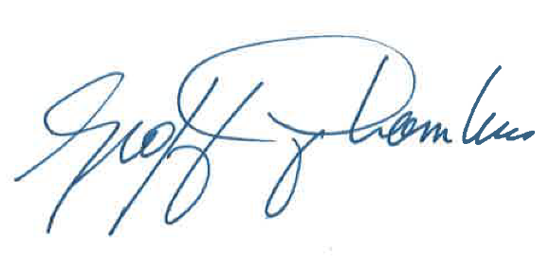

Kirwan Cox  Executive Director  Quebec English-language Production Council  1450 City Councillors #530  Montreal, Quebec H3A 2E6  qepc@bell.net  450-451-4664 |  | Geoffrey Chambers  President  Quebec Community Groups Network  1819 René-Lévesque W., Suite 400  Montreal, Quebec H3H 2P2

Guy Rodgers
Executive Director
English-language Arts Network
#708- 460 Ste-Catherine W.
Montreal, Quebec
H3B 1A7

APPENDIX 1

Questions as set out in the Terms of reference

Telecommunications Act and Radiocommunication Act

1. Universal Access and Deployment
1.1 Are the right legislative tools in place to further the objective of affordable high quality access for all Canadians, including those in rural, remote and Indigenous communities?
1.2 Given the importance of passive infrastructure for network deployment and the expected growth of 5G wireless, are the right provisions in place for governance of these assets?
2. Competition, Innovation, and Affordability
2.1 Are legislative changes warranted to better promote competition, innovation, and affordability?
3. Net Neutrality
3.1 Are current legislative provisions well-positioned to protect net neutrality principles in the future?
4. Consumer Protection, Rights and Accessibility
4.1 Are further improvements pertaining to consumer protection, rights, and accessibility required in legislation?
5. Safety, Security and Privacy
5.1 Keeping in mind the broader legislative framework, to what extent should the concepts of safety and security be included in the Telecommunications Act/Radiocommunication Act?
6. Effective Spectrum Regulation
6.1 Are the right legislative tools in place to balance the need for flexibility to rapidly introduce new wireless technologies with the need to ensure devices can be used safely, securely, and free of interference?
7. Governance and Effective Administration
7.1 Is the current allocation of responsibilities among the CRTC and other government departments appropriate in the modern context and able to support competition in the telecommunications market?
7.2 Does the legislation strike the right balance between enabling government to set overall policy direction while maintaining regulatory independence in an efficient and effective way?

Broadcasting Act

8. Broadcasting Definitions
8.1 How can the concept of broadcasting remain relevant in an open and shifting communications landscape?
8.2 How can legislation promote access to Canadian voices on the Internet, in both official languages, and on all platforms?
9. Broadcasting Policy Objectives
9.1 How can the objectives of the Broadcasting Act be adapted to ensure that they are relevant in today's more open, global, and competitive environment?
9.2 Should certain objectives be prioritized? If so, which ones? What should be added?
9.3 What might a new approach to achieving the Act's policy objectives in a modern legislative context look like?
10. Support for Canadian Content and Creative Industries
10.1 How can we ensure that Canadian and non-Canadian online players play a role in supporting the creation, production, and distribution of Canadian content?
10.2 How can the CRTC be empowered to implement and regulate according to a modernized Broadcasting Act in order to protect, support, and promote our culture in both official languages?
10.3 How should legislative tools ensure the availability of Canadian content on the different types of platforms and devices that Canadians use to access content?
11. Democracy, News and Citizenship
11.1 Are current legislative provisions sufficient to ensure the provision of trusted, accurate, and quality news and information?
11.2 Are there specific changes that should be made to legislation to ensure the continuing viability of local news?
12. Cultural Diversity
12.1 How can the principle of cultural diversity be addressed in a modern legislative context?
13. National Public Broadcaster
13.1 How should the mandate of the national public broadcaster be updated in light of the more open, global, and competitive communications environment?
13.2 Through what mechanisms can government enhance the independence and stability of CBC/Radio-Canada?
13.3 How can CBC/Radio-Canada play a role as a leader among cultural and news organizations and in showcasing Canadian content, including local news?
13.4 How can CBC/Radio-Canada promote Canadian culture and voices to the world, including on the Internet?
13.5 How can CBC/Radio-Canada contribute to reconciliation with Indigenous Peoples and the telling of Indigenous stories by Indigenous Peoples?
13.6 How can CBC/Radio-Canada support and protect the vitality of Canada's official languages and official language minority communities?
14. Governance and Effective Administration
14.1 Does the Broadcasting Act strike the right balance between enabling government to set overall policy direction while maintaining regulatory independence in an efficient and effective way?
14.2 What is the appropriate level of government oversight of CRTC broadcasting licensing and policy decisions?
14.3 How can a modernized Broadcasting Act improve the functioning and efficiency of the CRTC and the regulatory framework?
14.4 Are there tools that the CRTC does not have in the Broadcasting Act that it should?
14.5 How can accountability and transparency in the availability and discovery of digital cultural content be enabled, notably with access to local content?

APPENDIX 2

Statement to the
Broadcasting and Telecommunications Legislative Review Panel
from the
Official Language Minority Communities in Quebec
October 25, 2018

Thank you, Mme. Yale and members of this Panel, for meeting with us on this important topic. In fact, we can’t think of a more important subject. Your recommendations, and the Government’s decisions, will decide the digital and cultural future of our country in the 21st century.

We represent the official language minority (OLMC) in Quebec.

I am Kirwan Cox, Executive Director of the Quebec English-language Production Council (QEPC). We represent the English-language media production industry in Quebec. Our members produce over $100 million in production per year and represent over 3,000 people working in the industry. Let me introduce two members of our board: Arnie Gelbart (Galafilm), and Kenneth Hirsch (PMA Productions).

I am Guy Rodgers, Executive Director of ELAN. The English-language Arts Network of Quebec (ELAN) represents 8,000 English-speaking artists in Quebec. Many of these cultural workers are employed in the production of film, television, and video and ELAN provides resources to individuals for professional development and networking.

ELAN generally plays a supporting role to the Quebec English-language Production Council (QEPC) regarding industry and production issues. ELAN regularly collaborates with the Quebec Community Groups Network (QCGN) to represent the interests of Quebec's minority official language community regarding local content and regional reflection.

I am Chris Neal, a member of the Board of Directors of the Quebec Community Groups Network, and with me is Andrew Palucci, our intern, and student in Concordia University’s Public Policy and Public Administration masters program. The QCGN brings together 57 community sector organizations from across the province that serve the 1.1 million people who make up Canada’s English linguistic minority communities, which we refer to collectively as the English-speaking Community of Quebec. Both ELAN and QEPC are QCGN members.

Every federal institution, and that includes any board, commission or council, or other body or office, has a duty to ensure that positive measures are taken to enhance the vitality of the English and French linguistic minority communities in Canada, support and assist their development, and foster the full recognition and use of both English and French in Canadian society.

The QCGN believes this commitment should be written into Canada’s broadcasting and telecommunications acts. Those legislative instruments and their respective regulations require support for programming that protects and expresses the unique culture and perspectives of Canada’s English and French linguistic minorities. This principle needs to be enunciated clearly and unequivocally in the new legislation.

Next, we believe the public interest needs to be defined as more than a communications system located in Canada. It is a Canadian communications system that is strong enough to maintain our cultural sovereignty in the face of overwhelming pressure from our neighbour, the most powerful communicator in the world.

There can be no Canadian communications system, nor diversity of programming, without Canadian content. Cancon must be at the center of our national communications network. We must be able to communicate to, and with, ourselves as well as the world.

We must be able to take measures to encourage Canadians to access their own programming on the new digital platforms. If we can’t do that, we are not a country, we are not a nation-state. We are a market with no shared identity, and little shared future.

In an age of rampant “globalization” that masks cultural homogenization, how can we guarantee the survival of a Canadian vision? Of Canadian programming? Of a diversity of voices that includes our own, and includes the minorities within Canada?

The formula is simple. The execution of that formula is difficult.

We must protect our cultural sovereignty so we can control and regulate our market. Through regulation, we must assure that all players in the Canadian system raise sufficient funding to support Canadian programming. Sufficient funding is needed to create competitive quality programming. Competitive quality programming is needed to reach and maintain domestic audiences, especially in English.

We embrace new or digital technologies that allow Canadians to consume diverse content. We see it as a natural corollary of the evolution of Canadian programming that all players in the Canadian communications system, or domestic market, must contribute to Canadian content, regardless of the technologies or platforms they use to deliver that content to Canadians.

We need to repeat this. Every player in the Canadian communications system, or domestic market, must contribute to Canadian content. That is not only a question of fairness. It is essential if we are to have competitive programs that audiences want to see.

Furthermore, competitive quality programming will be attractive to larger foreign audiences, and we welcome that.

However, Cancon cannot be dependent on export markets for its survival. We need to fund Cancon primarily from within our domestic market.

Let’s be clear. A funding strategy dependent on foreign markets is illusory. French programming cannot generate sufficient foreign sales to survive. English programming funded by foreign markets will leave us with service production telling someone else’s stories, not our own, and eventually drive our best talent to Los Angeles.

We believe it is in the public interest to ensure that Canadians have access to their own stories, in both official languages, and the opportunity to tell those stories.

How do we do that?

First, we need to once again acknowledge that the Canadian broadcasting system is a “single system”. That single system must be subject to Canadian control and regulation.

Second, the Official Languages Act is not enough. English and French OLMC programming and production must be guaranteed in the new legislation. All elements of the broadcasting system, regardless of platform or role, should be required to support OLMC programming as well as Canadian programming. The details can be decided by the CRTC and PCH, but the principle needs to be enunciated clearly and unequivocally in the new legislation.

Third, key to that single system is the national broadcaster. The role of the public broadcaster has never been more important. CBC/SRC must have its independence guaranteed. CBC/SRC funding must be assured at an appropriate level to fulfill its growing mandate on all platforms.

CBC/SRC should be required to spend a minimum of its program budget, or production resources, on OLMC minorities. We would request a minimum of 10% of each production envelope.

Like the BBC, CBC should have a ten-year mandate with adequate and stable funding. The CBC board should have the power to choose its CEO.

Fourth, all Canadian broadcasters must have the resources to do more. They haven’t raised their license fees in over 10 years. They stick to the minimum Canada Media Fund (CMF) requirement of $315,000 per episode. CBC doesn’t put in more than C$1,000,000 in total license and CMF funding. That might generate a top-end Canadian drama costing about C$2,500,000 per episode like “Anne with an E”, “Rookie Blue”, or “Saving Hope”. These shows compete against average American dramas with C$5,000,000+ budgets up to top end mini-series like C$13,000,000 per episode for “Game of Thrones”.

Fifth, the key role of the Canada Media Fund (CMF) should be included in the new legislation. While the needs of the two OLMC minorities are different, in principle the two OLMC minorities should be treated equally. At present that is not the case.

The PCH-CMF Contribution Agreement requires that at least 10% of its French envelope be spent on French OLMC production. However, there is no minimum obligation for English OLMC production. We believe that at least 10% of the CMF’s English envelope must be spent on English OLMC production.

Sixth, all elements of the communications system operating in Canada, whether ISPs, traditional broadcasters, or over-the-tops like Netflix, Google or Facebook, must fund Canadian production.

Seventh, we support the request of the French CLOSM that the CRTC should include two national linguistic commissioners in addition to the regional commissioners. One representing the English language and the other representing the French language.

Finally, Canadians have to be able to easily locate their programming, whether through a traditional quota, a Cancon “discoverability” algorithm, both, or something else.

We would be happy to answer any questions you may have.

Thank you.

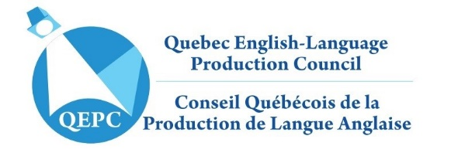
APPENDIX 3

May 7, 2018

Jérémy Gauthier
Policy Advisor
Minister of Canadian Heritage
15 Eddy St.
Gatineau, Québec K1A 0M5

Dear M. Gauthier,

Re: OLMC production crisis, loss of vitality, and positive measures

Thank you very much for your timely response to our email to Mr. Kalles, and our 2015-16 Production Report. As QEPC and QCGN have pointed out, we very much need to forge a robust communications link with the Minister to discuss OLMC cultural policy, and your email is timely and appreciated.

Last week, I met with representatives of the Department of Canadian Heritage (PCH), including Mr. Ripley and Ms. Mayes. We discussed the issues below, and they suggested that we needed to bring them to the attention of the Minister’s staff. I am undertaking that process with this letter.

English official language minority community (OLMC) production hit an historic low in 2015-16, falling more than half from a peak of $306m in 1999-00 to $127m. During this time, English OLMC production fell from a 22% share of total English Canadian production to only 7%.

As Graphs 2 and 3 demonstrate, this decline is unique among all regions in both languages. This loss of production is having a negative impact on OLMC vitality, including the loss of OLMC jobs, and the exodus of OLMC talent and youth from Quebec.
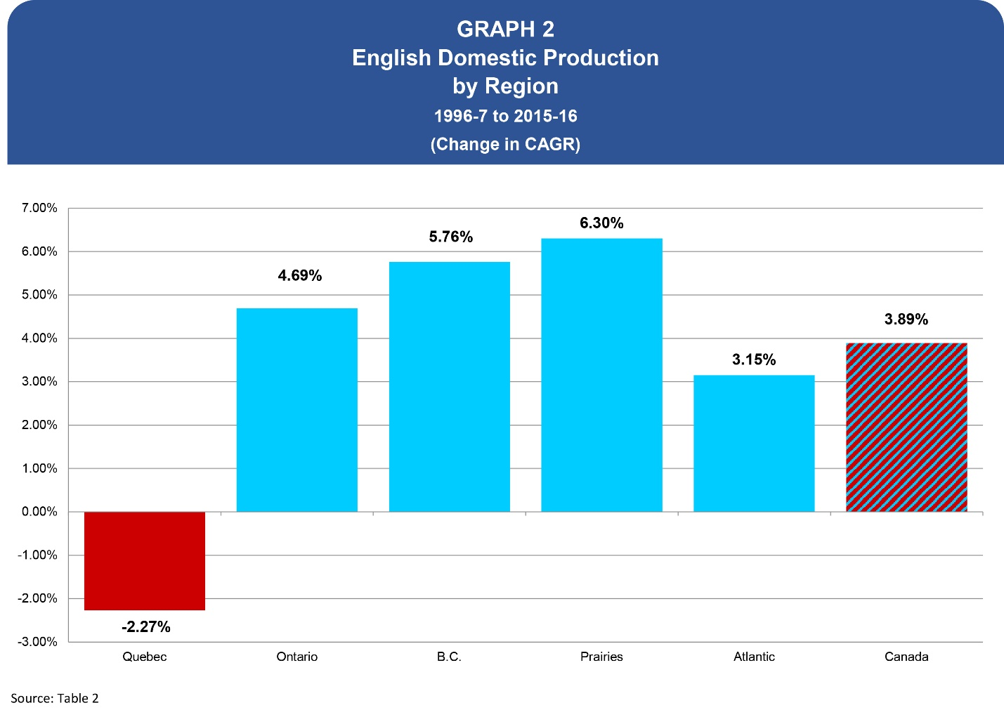

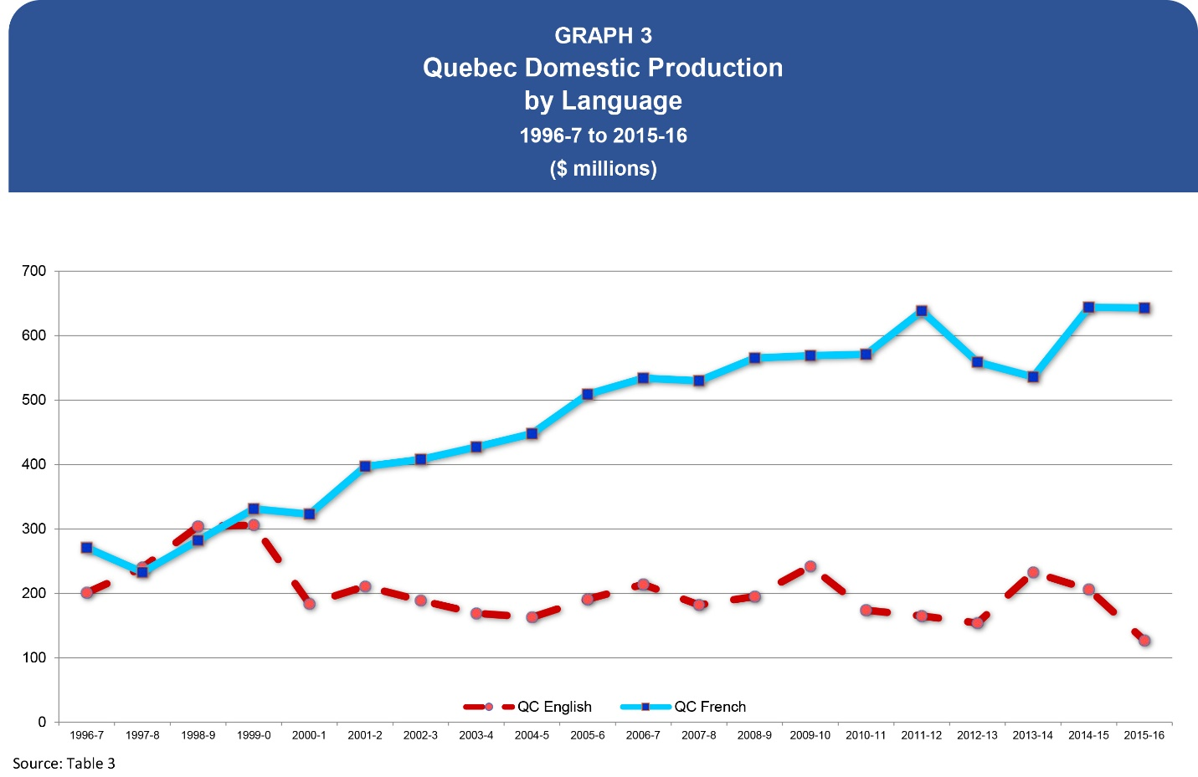

Following a complaint filed by QEPC in 2010 concerning these issues, the Office of the Commissioner of Official Languages (OCOL) investigated and decided in 2013 that PCH should:

“1) Include a provision that recognizes the English OLMC in the next contribution agreement that is signed with the Canada Media Fund for fiscal year 2013-2014.
2) Take measures, by the end of fiscal year 2012-13, to mitigate the impact of the uncertainty in yearly funding on the vitality and development of English OLMC.”

Subsequently, the Anglophone Minority Incentive (AMI) fund was established by the Canada Media Fund (CMF). This was a good first step, and helped CMF-funded OLMC production increase from $42m in 2012-13 to $61m in 2015-16.

However, as we can now see, while these measures helped reduce the rate of OLMC losses, they were clearly not sufficient to deal with the chronic decline of total OLMC production. At current funding levels, the AMI could not stop or reverse the production crisis the Quebec OLMC now faces.
We believe positive measures are now required to deal with the scope of this crisis. The PCH “Creative Canada” priorities given to CMF do not include OLMC production. As a result of the OLMC’s low priority and CMF’s financing challenges, AMI funding has been frozen at $4.5m for the third year in a row.
Now that CMF funding has itself been stabilized by PCH, the solution to the English OLMC production crisis is relatively simple. Follow the objectives of the Official Languages Act, and treat both English and French OLMCs equally.

First, as you can see in the QEPC Report, over the last six years CMF’s total English OLMC funding has jumped up and down like a yo-yo, between $8m and $18m. This has created uncertainty in the English OLMC’s yearly CMF funding. Graph 4 shows how volatile OLMC theatrical production has been, but it also shows that total OLMC television production has been declining despite the establishment of the AMI fund.

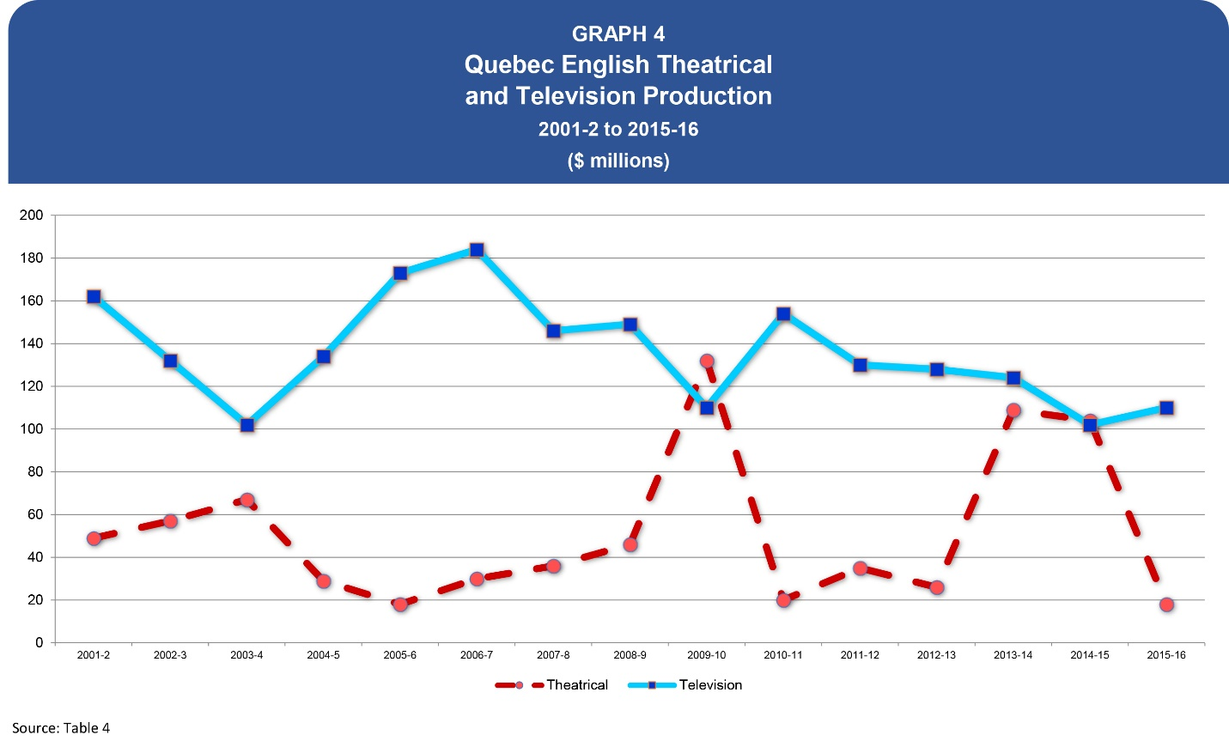

To meet our needs, and eliminate this uncertainty in CMF funding of English OLMC production, PCH should amend the PCH-CMF Contribution Agreement so it treats the English and French minorities equally. Now they aren’t treated equally. The Contribution Agreement says:

“The [Canada Media Fund] Corporation shall: (i) meet the Government’s policy objective of supporting French-language minority productions by ensuring a minimum 10% funding envelope, calculated on the amount allocated for French-language productions; (ii) consider what measures might be appropriate to address the impact, if any, of the uncertainty in yearly funding levels on the vitality and development of English-language minority communities;”

To be treated equally, both minorities should have the same minimum of 10% funding from their respective CMF envelopes. Like the French OLMC, the English OLMC producers remain vulnerable.

A 10% minimum English OLMC funding requirement would result in stabilizing total CMF English OLMC funding at about $20 million per year which meets our demonstrated needs.

Some may say that the English OLMC should receive a 5% minimum to achieve the same $10 million in funding that the French OLMC receives. We disagree. In fact, the Commissioner of Official Languages addressed this issue in his Report when he said positive measures should be based on the specific needs of each community. The two industries are quite different in size and history. In 2015-16, French OLMC production was $29 million. Even at an historic low, English OLMC production was five times larger at $127 million.

Providing a 10% English OLMC minimum can be done without new monies. The funds are available within the CMF’s $352 million budget (2018-19). If necessary, this money could be found through transfers from the CMF’s Broadcast Performance Envelope (BPE) fund.
Second, unlike the French OLMC, the English OLMC does not have a collaboration agreement with PCH. It is time for PCH to negotiate a cultural collaboration agreement with the English OLMC such as the NFB has done.

We believe the Minister should eliminate these disparities between the English and French OLMCs. Considering the current production crisis, we believe the Minister must take immediate and strong positive measures to support English-language production in Quebec.
We would like to meet with the Minister’s staff to examine the severity of this crisis, review our needs, and discuss the positive measures the Minister can take to fulfill OCOL’s 2013 recommendation that PCH:

“…mitigate the impact of the uncertainty in yearly funding on the vitality and development of English OLMC”.

Thank you.

Yours truly,

Kirwan Cox
Executive Director
Quebec English-language Production Council
qepc@bell.net
450-451-4664

*** End of Document ***

CRTC 1999-97, #75
See QEPC, Canadian Regional Audiovisual Production Report, 1996-7 to 2015-16, Dec., 2017, Table 2, or Table 2 in subsequent reports at qepc@bell.net. This historic data is from the Canadian Audio-Visual Certification Office (CAVCO) which is a division of PCH, and manages Federal tax credits for both domestic (CPTC) and service (PSTC) independent production. These statistics are from CPTC data which goes back to 1996-7.
CRTC 2010-167, #46
Broadcasting Act 1991, s.3(1)(m)(iv)
Op. Cit., QEPC, Canadian Regional Audiovisual Production Report, 1996-7 to 2015-16, Dec., 2017, and earlier editions.
See CRTC 2018-265, “Rogers – Licence renewal for various terrestrial broadcasting distribution undertakings”, #40-52
See CRTC 2018-269 below, and CRTC 2016-224 “Policy framework for local and community television”, #151-166, #199-205
CRTC 2016-343, #128-132
See CRTC 2017-429
See CRTC 2015-32 above
Broadcasting Act 1991, s.3(1)(m)(iv)
Commissioner of Official Languages, “Final Investigation Report on the Canada Media Fund Program Guidelines”, ref: 0654-2010-PCH1, Jan.17, 2013
Ibid, p.13
See CRTC 1999-84, CRTC 1999-197, and CRTC 2012-409.
CMF has a detailed definition of OLMC production based on consultation with French and English OLMCs, and Indigenous producers. CRTC has decided to review its definition. See Notice of Consultation CRTC 2018-488.
PCH, “Contribution by the Department to the Canada Media Fund 2017-18”, Appendix A, Contribution Objectives, page 23. See May 7, 2018, QEPC letter to PCH appended below.
See QEPC letter to Jérémy Gauthier, PCH Policy Adviser, May 7, 2018, appended below.
See “Statement to the Broadcasting and Telecommunications Legislative Review Panel from the Official Language Minority Communities in Quebec, October 25, 2018”
See ALLIANCE DES PRODUCTEURS FRANCOPHONES DU CANADA PRÉSENTATION DEVANT LE COMITÉ YALE, Nov.13, 2018, and NOTES POUR L’INTERVENTION DE L’APFC DEVANT LE COMITÉ SÉNATORIAL PERMANENT DES TRANSPORTS ET DES COMMUNICATIONS, Oct. 24, 2018.
QEPC, Canadian Regional Audiovisual Production Report, 1996-97 to 2015-16, Dec., 2017; See Table 2 and appended press release with link to the Report at QEPC.ca
See OCOL, “Final Investigation Report on the Canada Media Fund Program Guidelines”, OCOL reference 0654-2010-PCH1; CITS (WebCIMS) No. 84314; Jan. 17, 2013; page 13.
See PCH, “Creative Canada Policy Framework”, Sept. 28, 2017, s.1.2 “Invest in television and digital media content”; which emphasizes program development, innovative projects in the Experimental Stream, indigenous production, and international marketing.
See the Official Languages Act, s.2 “The purpose of this Act is to (a) ensure respect for English and French as the official languages of Canada and ensure equality of status and equal rights and privileges as to their use in all federal institutions…”
Op. cit. QEPC Report, see Table 14.
PCH, “Contribution by the Department to the Canada Media Fund 2017-18…”, Appendix A, Contribution Objectives, page 23.“
Op. cit., OCOL Report, p. 4: “Pursuant to the [House of Commons Standing Committee on Official Languages] Committee’s recommendations, since 2004, the Government of Canada has ensured that the CTF set aside a minimum of 10% of its French-language funding for French-language productions in minority contexts. When establishing the CMF, Canadian Heritage maintained the same dedicated funding for French OLMC, because it considered that Francophone producers in a minority situation remained potentially vulnerable.”
Ibid., OCOL Report, p. 9: “The Office of the Commissioner of Official Languages is of the view that Canadian Heritage’s obligation under Part VII of the Act to take positive measures to enhance the vitality of OLMCs and to support and assist their development goes beyond a per capita funding analysis comparison between the two minority communities. Each OLMC has its own particular set of challenges that must be identified in order to develop programs or policies that respond to the specific needs of that community.”

